Project Design Phase-II
Data Flow Diagram & User Stories

Date | 01 July 2026
Team ID
Project Name | Customer Registry
Maximum Marks | 4 Marks

Data Flow Diagrams:
A Data Flow Diagram (DFD) is a traditional visual representation of the information flows within a system. A neat and clear DFD can depict the right amount of the system requirement graphically. It shows how data enters and leaves the system, what changes the information, and where data is stored.

DFD Level-0 (Context Diagram)
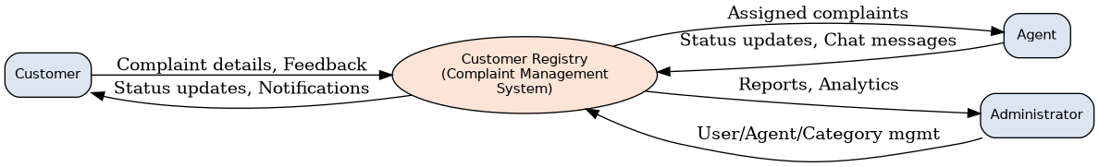

DFD Level-1
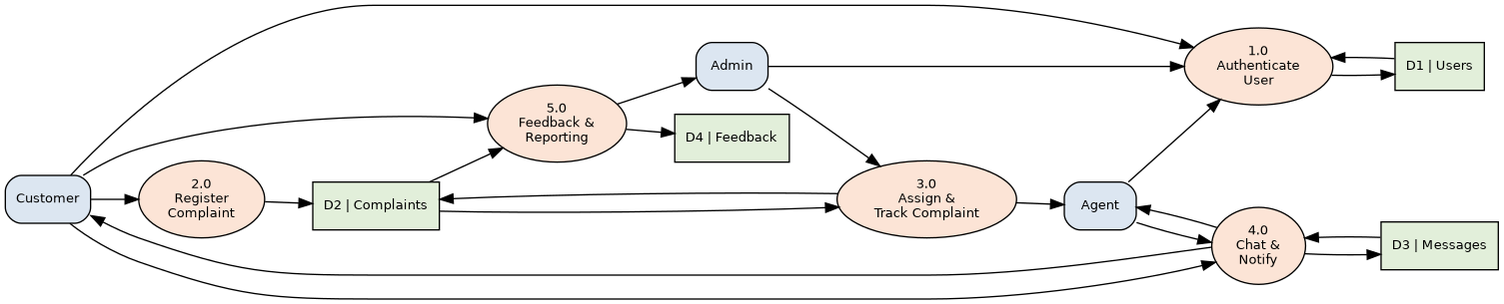

User Stories
Use the below template to list all the user stories for the product.

User Type | Functional Requirement (Epic) | User Story Number | User Story / Task | Acceptance Criteria | Priority | Release
Customer (Web/Mobile user) | Registration | USN-1 | As a user, I can register by entering my email, password, and confirming my password. | I can access my dashboard after successful registration. | High | Sprint-1
 |  | USN-2 | As a user, I will receive a confirmation email once I have registered. | I can receive the confirmation email and click confirm. | High | Sprint-1
 | Login | USN-3 | As a user, I can log into the application by entering email & password. | I can log in and land on my dashboard. | High | Sprint-1
 | Dashboard | USN-4 | As a user, I can view a summary of all my complaints with their current status. | Dashboard shows total, open, in-progress, and resolved complaints. | High | Sprint-1
 | Raise Complaint | USN-5 | As a user, I can raise a complaint by selecting a category, description, and attaching files. | Complaint is saved with a unique complaint ID and status 'Open'. | High | Sprint-2
 | Track Complaint | USN-6 | As a user, I can track the real-time status and timeline of my complaint. | Timeline shows each status change with date and time. | High | Sprint-2
 | Chat | USN-7 | As a user, I can chat in real time with the agent assigned to my complaint. | Messages are delivered instantly and stored in history. | Medium | Sprint-3
 | Feedback | USN-8 | As a user, I can rate and give feedback once my complaint is resolved. | Rating and comments are saved against the complaint. | Medium | Sprint-3
Agent | Login & Dashboard | USN-9 | As an agent, I can log in and view all complaints assigned to me. | Dashboard lists assigned complaints sorted by priority/date. | High | Sprint-2
 | Update Status | USN-10 | As an agent, I can update the status of a complaint (In-Progress/Resolved). | Status change reflects instantly on the customer's tracker. | High | Sprint-2
 | Chat | USN-11 | As an agent, I can chat with the customer to clarify complaint details. | Chat window shows full conversation history. | Medium | Sprint-3
Administrator | Manage Users | USN-12 | As an admin, I can view, activate, or deactivate customer and agent accounts. | Admin can search and update account status. | High | Sprint-3
 | Assign Complaints | USN-13 | As an admin, I can assign or reassign complaints to available agents. | Assigned agent is notified and complaint owner is updated. | High | Sprint-3
 | Manage Categories | USN-14 | As an admin, I can create, edit, or remove complaint categories. | Category changes reflect immediately in the complaint form. | Medium | Sprint-4
 | Reports & Analytics | USN-15 | As an admin, I can view dashboard analytics on complaint volume and resolution time. | Charts display accurate, up-to-date statistics. | Medium | Sprint-4

